**Employee Training Management System** Final Project

Contents

1 Project Overview 1

1.1.1 Brief introduction of the project. 1

1.1.2 Purpose of the project. 2

1.1.3 Goals of the project: 2

2 Project Scope 2

2.1.1 Platforms and devices the mobile app will support (e.g., iOS, Android). 2

2.1.2 Key features and functionalities of the app. 2

3 Architecture and Technology Stack 3

3.1.1 Overall architecture of the Employee Training Management System (ETMS) application. 3

3.1.2 Technology stack (e.g., programming languages, frameworks, libraries). 4

3.1.3 Rationale behind the chosen technology stack. 4

4 Application Components 6

4.1.1 Main components of the app. 6

4.1.2 Purpose of each component. 7

5 User Interface Design 8

5.1.1 User interface (UI) design approach. 8

5.1.2 Tools and Databases Used. 10

6 Risks and Mitigation Strategies 12

6.1.1 Potential risks and challenges associated with the project. 12

# Project Overview

### Brief introduction of the project.

The Employee Training Management System (ETMS) project aims to revolutionize the training process within our organization by providing a centralized platform for interns and employees to access, track, and complete their training modules efficiently. With personalized assessment reports and robust data security measures, the ETMS ensures streamlined training management while prioritizing user privacy and engagement.

### Purpose of the project.

The purpose of the Employee Training Management System (ETMS) project is to address the challenges associated with traditional training methods by implementing a comprehensive digital solution. By centralizing training resources, tracking progress, and providing personalized assessments, the ETMS aims to enhance the effectiveness and efficiency of employee development initiatives. Ultimately, the project seeks to optimize learning outcomes, improve employee performance, and foster a culture of continuous learning within the organization.

### Goals of the project:

The goals of the Employee Training Management System (ETMS) project are multi-faceted and aim to address various challenges while enhancing organizational effectiveness and employee development. Primarily, the project seeks to streamline and optimize the training process by providing a centralized platform for managing training resources, tracking progress, and evaluating performance. By implementing personalized assessment reports and predictive analytics, the ETMS aims to tailor training experiences to individual needs, thereby improving engagement and learning outcomes. Additionally, the project aims to enhance data-driven decision-making through the integration of Power BI dashboards, enabling stakeholders to monitor key performance indicators (KPIs) and identify areas for improvement. Ultimately, the overarching goals of the ETMS project are to foster a culture of continuous learning, drive organizational growth, and empower employees to reach their full potential.

# Project Scope

### Platforms and devices the mobile app will support (e.g., iOS, Android).

|  |  |
| --- | --- |
| Platforms | Version |
| iOS | 11 and above |
| Android | 10 and above |

### Key features and functionalities of the app.

* User Authentication and Role-Based Access Control: The system ensures secure access for users through robust authentication mechanisms while allowing administrators to assign specific roles and permissions based on their responsibilities within the organization.
* Personalized Dashboards: Administrators and employees are provided with customized dashboards tailored to their needs, offering intuitive interfaces to effectively manage and monitor training activities, progress, and performance metrics.
* Comprehensive Management Tools: Administrators have access to a suite of tools for seamless creation, scheduling, and tracking of training resources, including user accounts, trainers, training modules, quizzes, and sessions, facilitating efficient training administration.
* Predictive Analytics and Assessment Reports: Leveraging machine learning models, the system predicts training outcomes and generates personalized assessment reports for individual users, offering valuable insights into performance and recommending suitable training paths.
* Visualization of Key Performance Indicators: Power BI dashboards enable stakeholders to visualize and analyze key performance indicators related to training activities, facilitating data-driven decision-making and strategic planning.
* Robust Data Security Measures: The system implements stringent data security measures such as encryption and access controls to safeguard sensitive information, ensuring compliance with data privacy regulations and protecting user confidentiality.
* Automated Documentation Generation: Through dbt integration, the system automatically generates comprehensive documentation for data models, lineage, and dependencies, enhancing transparency, compliance, and ease of maintenance in data management processes.

# Architecture and Technology Stack

### Overall architecture of the Employee Training Management System (ETMS) application.

The Employee Training Management System (ETMS) application is architected to ensure scalability, reliability, and efficiency in managing employee training processes. The architecture comprises the following components:

**Client-Side Interface:**

The client-side interface represents the user-facing aspect of the application, accessible through web browsers or dedicated desktop applications. It provides a user-friendly interface for employees and administrators to interact with the training system. Users can access personalized dashboards, view training progress, schedule sessions, and generate reports. The interface is designed for compatibility across different web browsers and operating systems, ensuring a consistent user experience.

**Application Logic Layer:**

The application logic layer forms the backbone of the ETMS, housing the core business logic and functionality. It manages user requests, orchestrates data retrieval and storage, and enforces business rules and validations. This layer handles tasks such as user authentication, training plan generation, progress tracking, and assessment scoring. By centralizing the application logic, the system ensures consistency, reliability, and maintainability across different modules and features.

### Technology stack (e.g., programming languages, frameworks, libraries).

**Programming Languages:**

* JavaScript: Used for both front-end and back-end development.
* Python: Utilized for scripting, data processing, and machine learning tasks.

**Frameworks and Libraries:**

* React.js: A JavaScript library for building interactive user interfaces. Utilized for the client-side interface to create dynamic and responsive user experiences.
* Node.js: A JavaScript runtime environment enabling server-side development, utilized for building the back-end logic and APIs.
* Express.js: A minimalist web framework for Node.js, used for creating RESTful APIs and handling server-side routing and middleware.
* MongoDB: A NoSQL database for storing and managing training data, user information, and session details.
* Snowflake: A cloud-based data warehousing platform for storing and analyzing large volumes of data generated by the application.
* dbt (Data Build Tool): Used for data transformation and modeling within Snowflake, enabling the creation of analytical datasets and documentation generation.
* scikit-learn: A machine learning library for Python, utilized for building and training machine learning models to predict training outcomes and provide personalized recommendations.
* Material UI: A popular React UI framework providing pre-designed components and themes for building modern, responsive web applications.

### Rationale behind the chosen technology stack.

**1. Scalability and Performance:**

Node.js and MongoDB were chosen for their scalability and performance characteristics, allowing the application to handle large volumes of data and user interactions efficiently.

**2. Flexibility and Modularity:**

React.js was selected for the front-end development due to its component-based architecture, which promotes code reusability, modularity, and ease of maintenance.

• Express.js provides a lightweight and flexible framework for building RESTful APIs, enabling easy integration with other components of the stack.

**3. Data Management and Analysis:**

MongoDB serves as the database for storing and managing training data, offering flexibility in schema design and scalability for handling diverse data types.

Snowflake was chosen as the data warehousing platform for its cloud-based architecture and powerful analytics capabilities, facilitating advanced data analysis and reporting.

**4. Machine Learning Capabilities:**

Python and scikit-learn were selected for machine learning tasks, allowing the application to leverage predictive analytics for training outcome predictions and personalized recommendations.

**5. User Interface and Experience:**

Material UI and Bootstrap were chosen for their extensive collection of pre-designed components, themes, and responsive design features, enabling the creation of visually appealing and user-friendly interfaces.

**6. Integration and Ecosystem Support:**

The selected technologies have strong community support and rich ecosystems, providing access to a wide range of libraries, tools, and resources for development, deployment, and maintenance.

**7. Alignment with Project Goals:**

The chosen technology stack aligns well with the project's goals of delivering a scalable, performant, and user-friendly Employee Training Management System that supports advanced data analysis, machine learning, and intuitive user interfaces.

# Application Components

### Main components of the app.

**1. User Management Module:**

• Allows administrators to create, update, and manage user accounts for employees, trainers, and administrators.

• Provides functionalities for user authentication, role-based access control, and user profile management.

**2. Training Management Module:**

• Enables administrators to create, schedule, and manage training programs, modules, and sessions.

• Facilitates the assignment of training materials, resources, and assessments to users based on their roles and requirements.

**3. Progress Tracking Module:**

• Allows employees to track their training progress, view completed modules, and monitor upcoming sessions.

• Provides visualizations and reports on individual and team progress to administrators for performance monitoring.

**4. Assessment and Reporting Module:**

• Facilitates the creation and administration of assessments, quizzes, and tests to evaluate user knowledge and skills.

• Generates personalized assessment reports for users based on their performance, providing insights and recommendations for improvement.

**5. Machine Learning Integration:**

• Integrates machine learning models for predictive analytics, allowing the system to predict training outcomes, recommend personalized learning paths, and estimate completion times.

**6. Data Security and Compliance Module:**

• Implements data encryption, access controls, and compliance measures to ensure the security and privacy of user data.

• Ensures compliance with data protection regulations and industry standards to safeguard sensitive information.

**7. Integration with External Tools:**

• Integrates with external tools and services such as Power BI for advanced analytics and visualization, enhancing decision-making and strategic planning capabilities.

**8. Documentation and Documentation Generation Module:**

• Automatically generates documentation for data models, lineage, and dependencies using dbt, ensuring transparency and compliance in data management processes.

### Purpose of each component.

**1. User Management Module:**

• Purpose: Manages user accounts, authentication, and permissions within the system.

• Allows administrators to create, update, and delete user accounts.

• Ensures secure access to training resources based on user roles and permissions.

**2. Training Management Module:**

• Purpose: Facilitates the creation, scheduling, and administration of training programs.

• Allows administrators to define training modules, sessions, and resources.

• Enables assignment of training materials and assessments to users.

**3. Progress Tracking Module:**

• Purpose: Tracks and monitors the progress of users in their training activities.

• Allows employees to view their completed modules, upcoming sessions, and overall progress.

• Provides administrators with insights into individual and team progress for performance monitoring.

**4. Assessment and Reporting Module:**

• Purpose: Evaluates user performance through assessments and generates reports.

• Administers quizzes, tests, and assessments to measure user knowledge and skills.

• Generates personalized assessment reports based on user performance, providing insights and recommendations.

**5. Machine Learning Integration:**

• Purpose: Integrates machine learning models for predictive analytics and personalized recommendations.

• Predicts training outcomes, completion times, and recommends tailored learning paths for users.

• Enhances training effectiveness and efficiency by leveraging predictive insights.

**6. Data Security and Compliance Module:**

• Purpose: Ensures the security and compliance of user data within the system.

• Implements data encryption, access controls, and compliance measures to protect sensitive information.

• Ensures adherence to data protection regulations and industry standards.

**7. Integration with External Tools:**

• Purpose: Integrates with external tools and services for advanced analytics and visualization.

• Enables the use of tools like Power BI for data analysis, reporting, and decision-making.

• Enhances the system's capabilities by leveraging external resources and expertise.

**8. Documentation and Documentation Generation Module:**

• Purpose: Generates documentation for data models, lineage, and dependencies.

• Provides transparency and compliance in data management processes.

• Enables stakeholders to understand and maintain data infrastructure efficiently.

# User Interface Design

### User interface (UI) design approach.

|  |  |
| --- | --- |
|  |  |

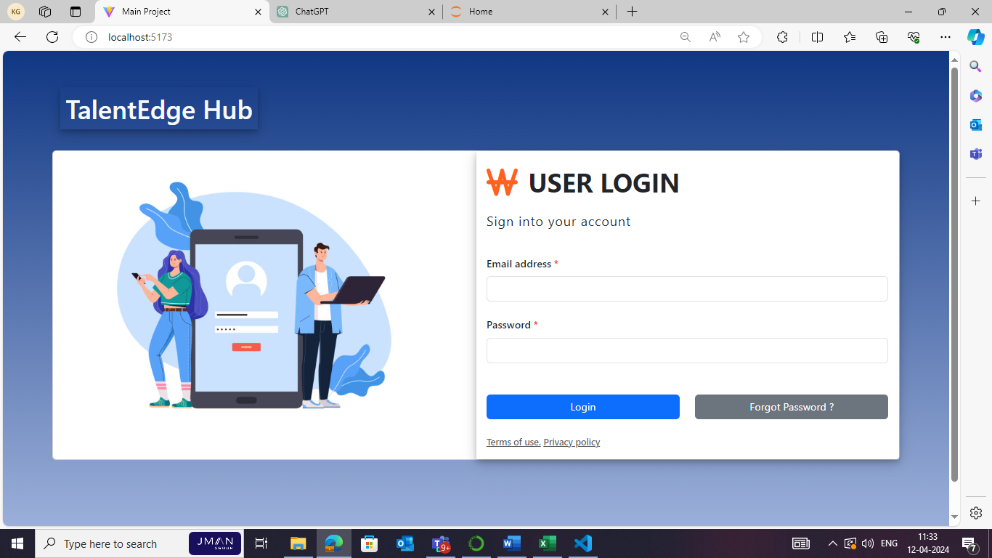

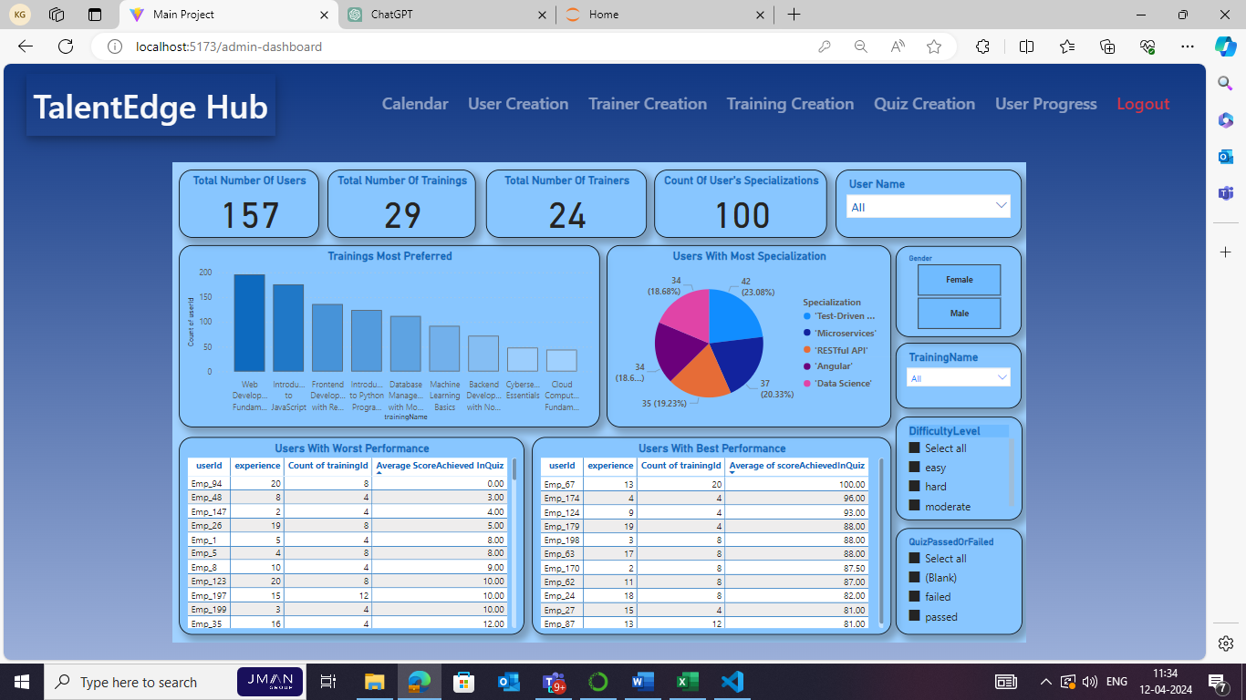

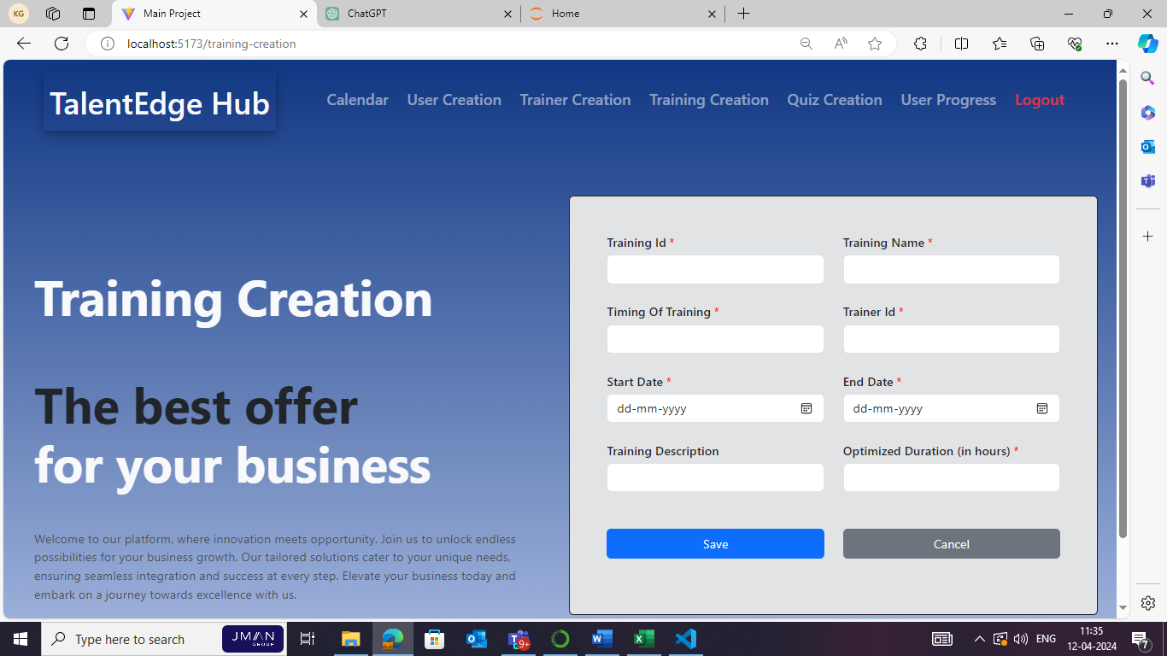

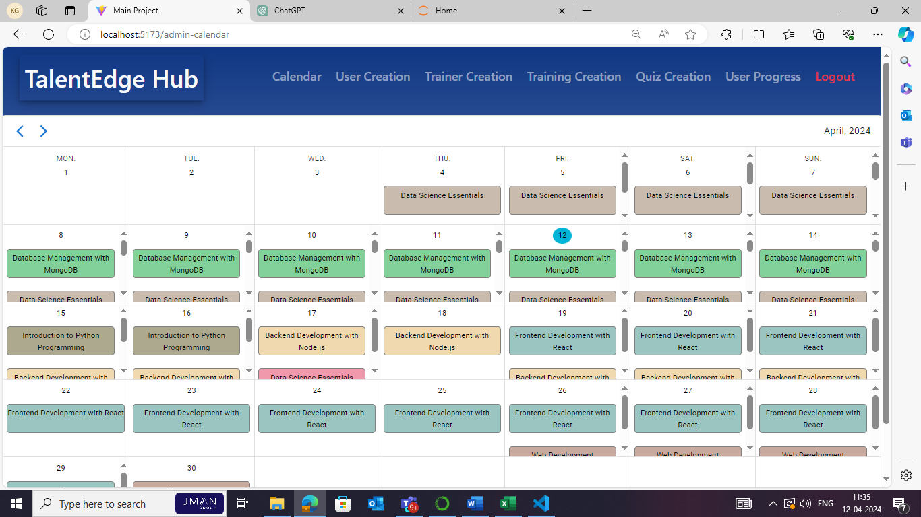

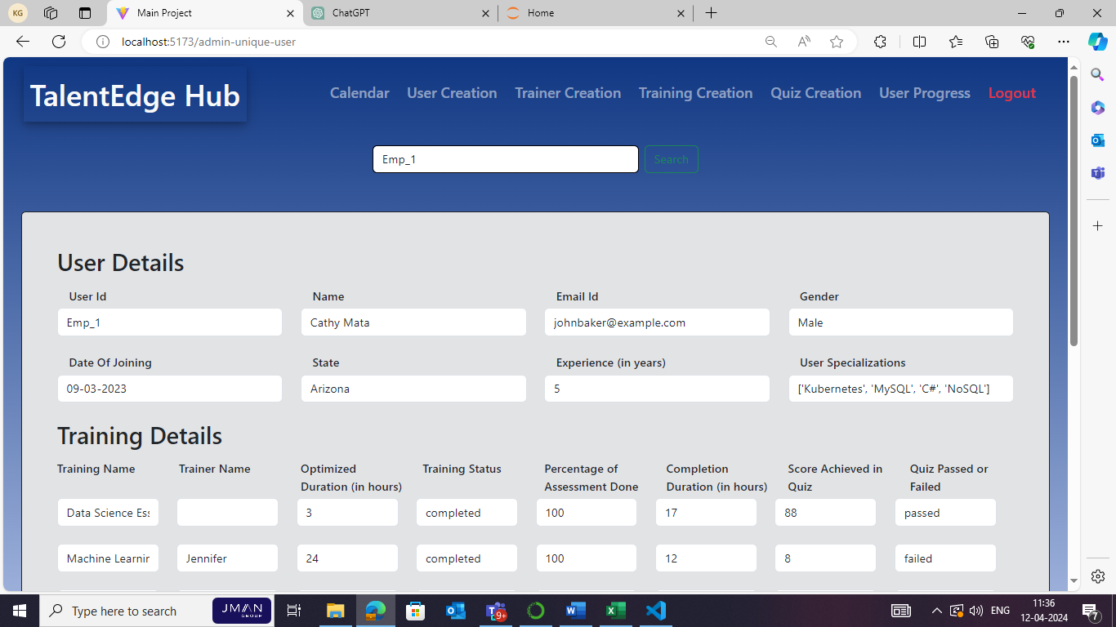

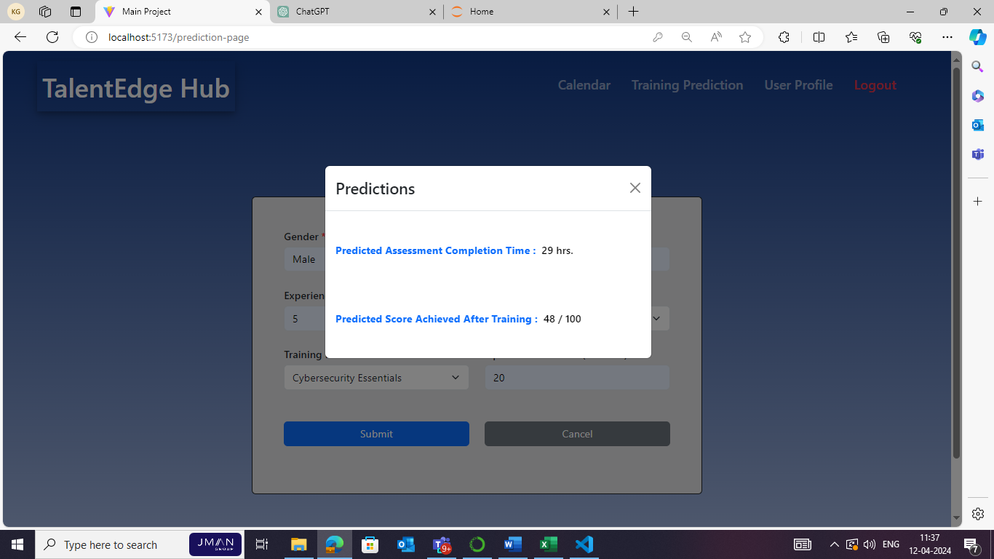

### Tools and Databases Used.

**Snowflake**

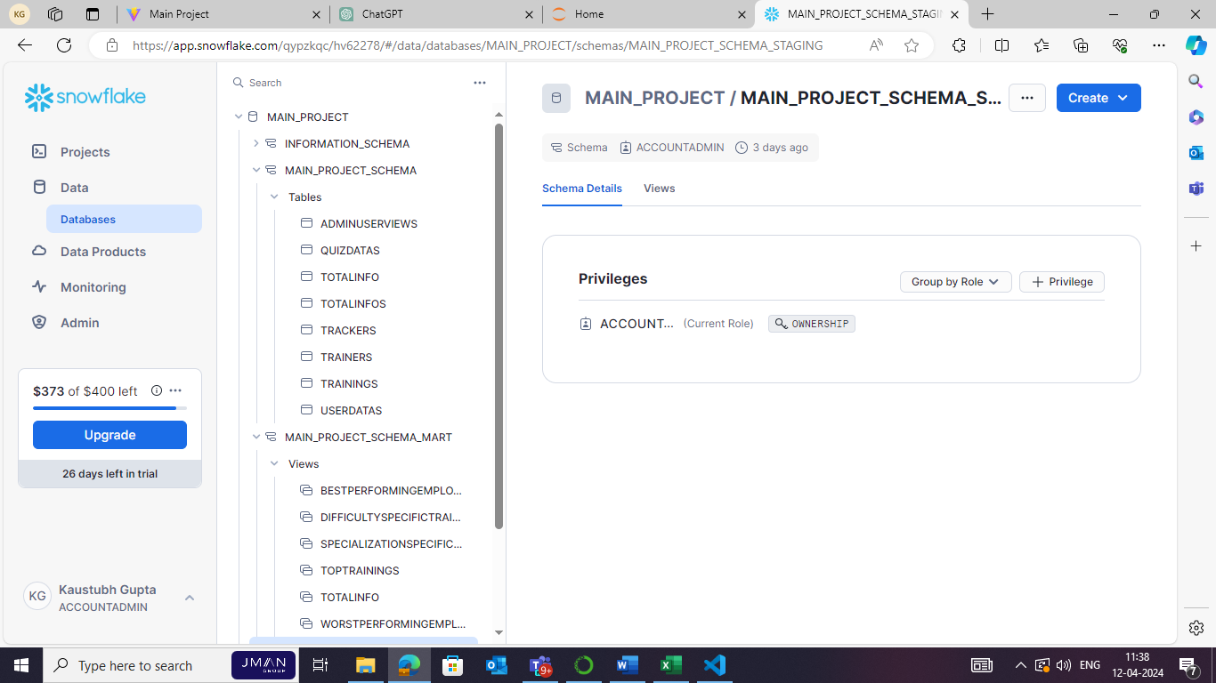

**MongoDB**

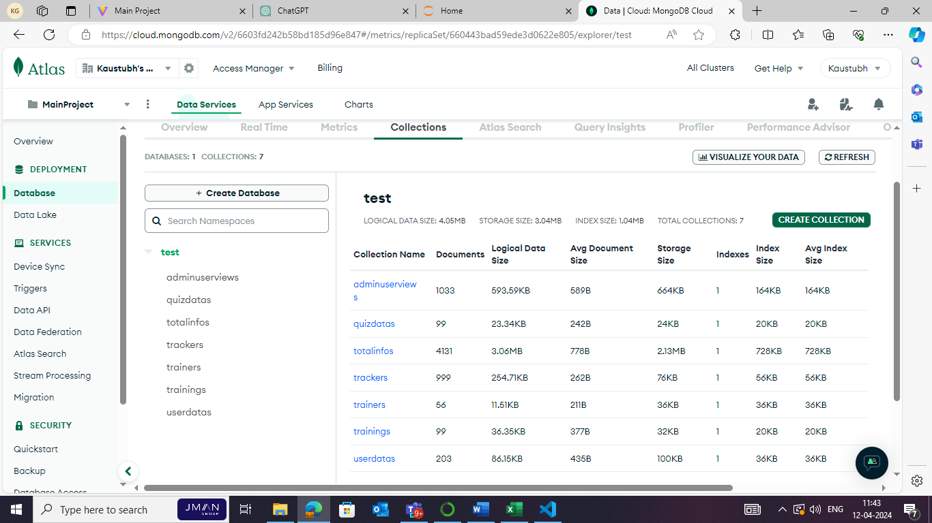

**Power BI**

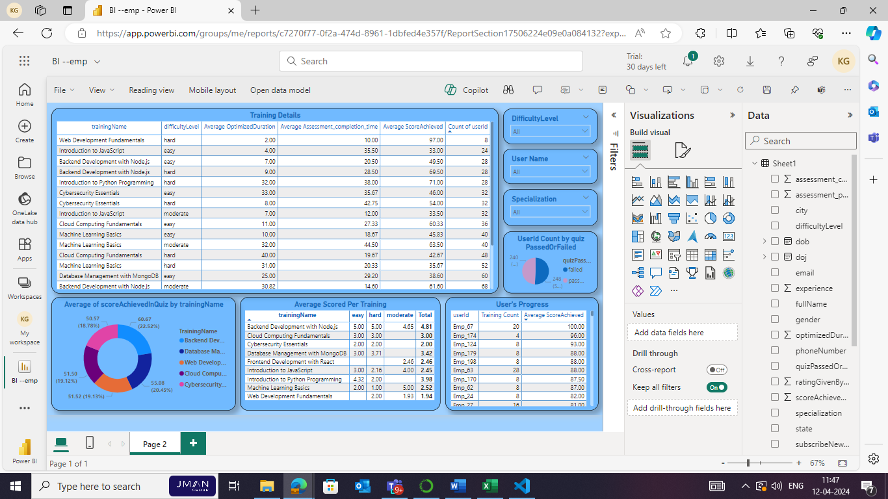

**DBT**

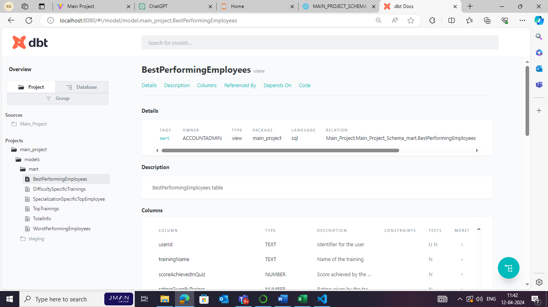

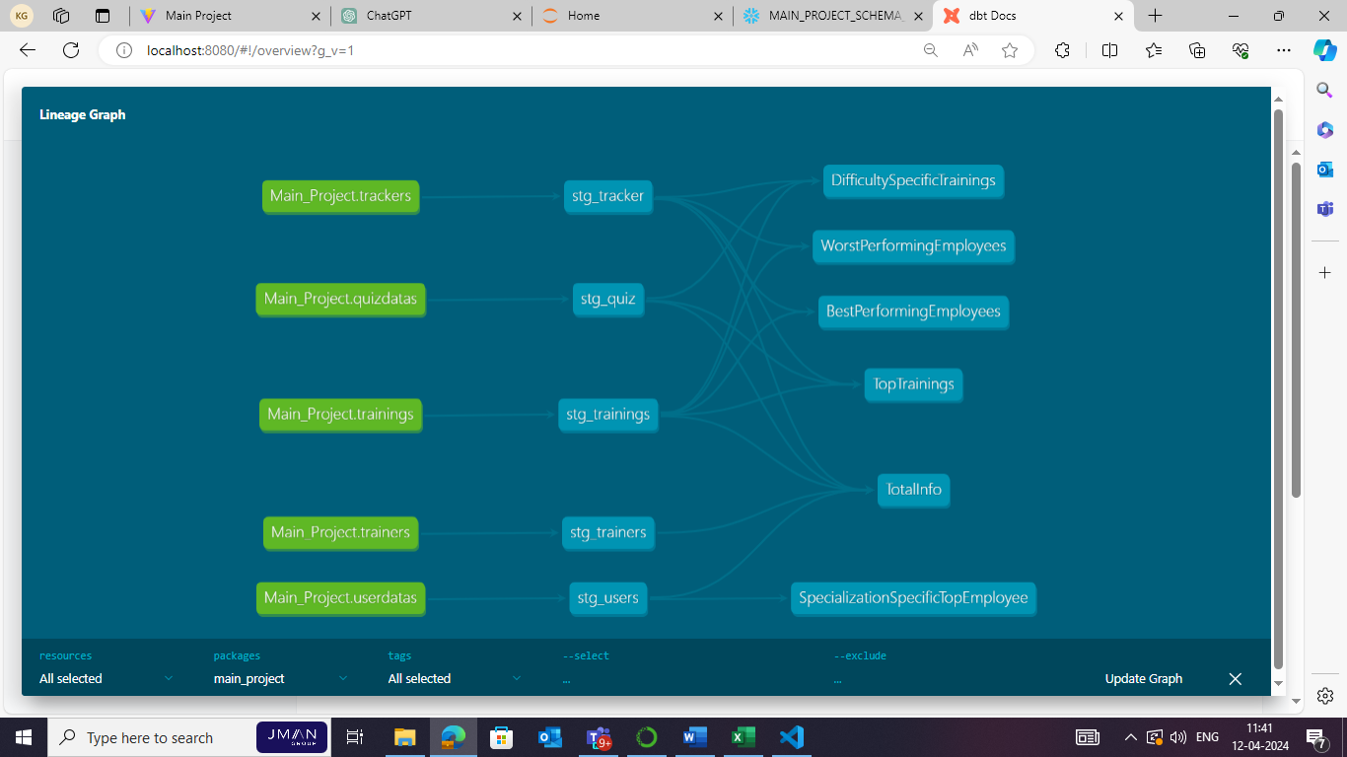

# Risks and Mitigation Strategies

### Potential risks and challenges associated with the project.

1. **Data Security Breaches:**
   * Risk: Unauthorized access to sensitive user data could result in breaches of privacy and data security.
   * Mitigation: Implement robust encryption techniques, access controls, and regular security audits to protect user data. Conduct employee training on data security best practices to mitigate internal risks.
2. **System Downtime:**
   * Risk: Technical issues or server failures could lead to system downtime, disrupting training activities and user access.
   * Mitigation: Implement redundancy and failover mechanisms to minimize downtime. Conduct regular maintenance and testing to identify and resolve potential issues proactively. Provide users with timely updates and notifications during maintenance windows.
3. **Integration Challenges:**
   * Risk: Integration with external tools or services may encounter compatibility issues or require additional development effort.
   * Mitigation: Conduct thorough testing and validation during the integration phase to identify and address any compatibility issues early. Collaborate closely with external vendors or service providers to ensure smooth integration and resolve any technical hurdles promptly.
4. **User Adoption and Training:**
   * Risk: Low user adoption or resistance to change could hinder the successful implementation of the ETMS.
   * Mitigation: Develop comprehensive training materials and conduct user training sessions to familiarize employees with the system's features and functionalities. Solicit feedback from users and address any concerns or challenges to promote acceptance and adoption.
5. **Data Quality and Integrity:**
   * Risk: Inaccurate or incomplete data could impact the effectiveness of training programs and analytics.
   * Mitigation: Implement data validation checks and ensure data integrity throughout the system. Establish data governance policies and procedures to maintain high-quality data. Regularly monitor and cleanse the data to identify and correct any discrepancies.
6. **Scalability Issues:**
   * Risk: Rapid growth or increased user demand could strain system resources and impact performance.
   * Mitigation: Design the system with scalability in mind, utilizing scalable architecture and cloud-based resources. Monitor system performance and capacity regularly, and scale resources dynamically to meet growing demand. Conduct load testing to identify potential bottlenecks and optimize system performance.
7. **Regulatory Compliance:**
   * Risk: Failure to comply with relevant data protection regulations and industry standards could result in legal and financial repercussions.
   * Mitigation: Stay informed about relevant regulations and ensure compliance with data protection laws such as GDPR or HIPAA. Implement appropriate data security measures, privacy policies, and consent mechanisms to protect user data and mitigate compliance risks. Regularly audit and update compliance procedures to align with evolving regulatory requirements.